# QUESTION 1

You are given a task a lecturer at your college to write a complete program which will allow the user to calculate Interest

The area formula is:

*Interest = Principal*Rate*Time*

**BELOW IS THE GRAPHIC USER INTERFACE (GUI) DIAGRAM**

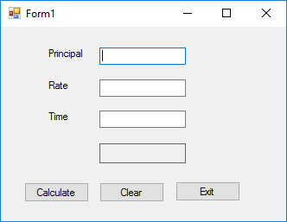

**BELOW IS THE UNIFIED MODELLING LANGUAGE (UML) DIAGRAM**

Interest

-Principal

-Rate

-Time

+Interest()